Vensim Installation guideline

* Open the Ventana System website:

<https://vensim.com/download/>

* Click on Free Downloads

,

* Open the download window
* Tick the anti-spam box
* As the product, select Vensim PLE version
* Select your operating system
* Type your name and mail address
* Click on Download software

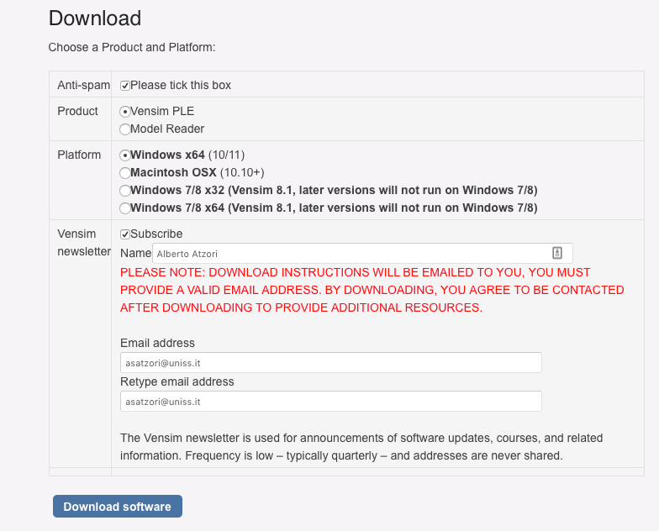

* You will receive the download instructions by email (**This can take a couple of hours**). When you receive the email, click on the link in the email.
* Then Install the software
* At installation, select **“Install PLE for academic …”** option in Windows, and select **“Academic/Educational”** option for the install type in Mac.



Windows:

Mac:

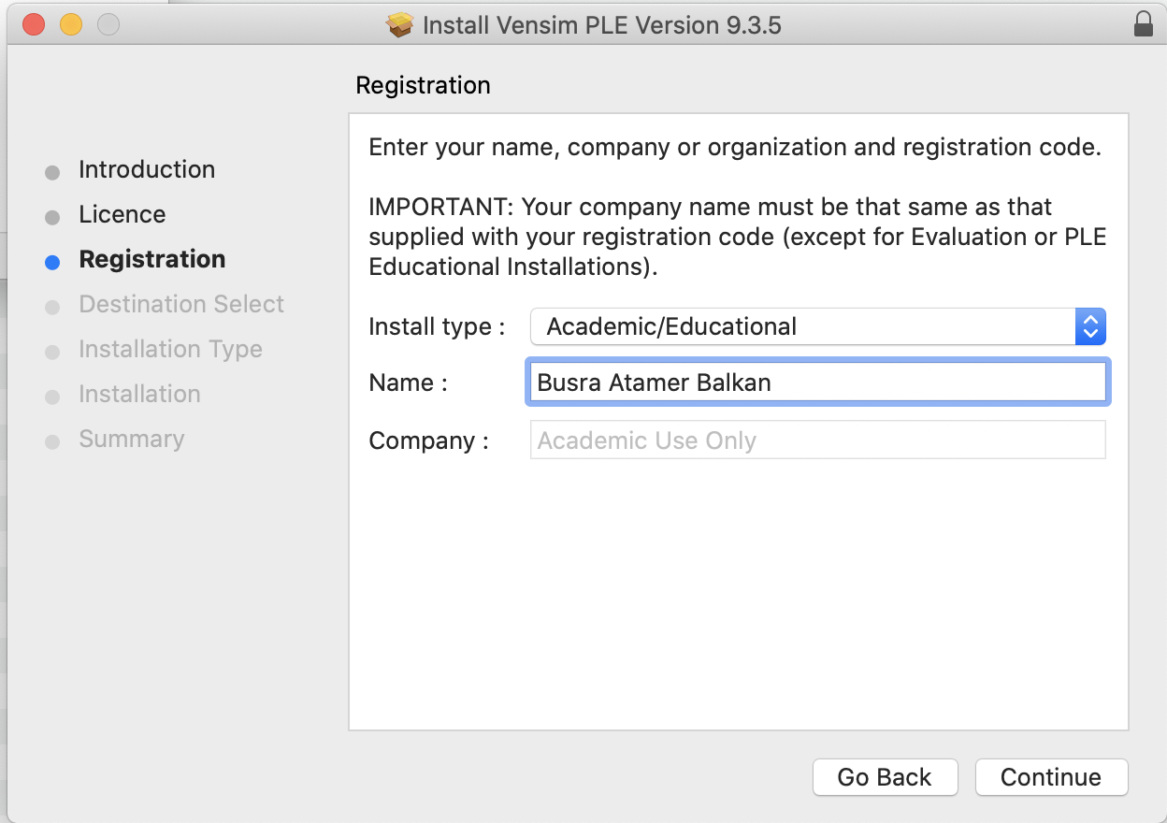

Part 2:

Step1) Open Vensim and look at the software first page.

Step 2) Look at this Video tutorial to have a first idea of the Software Vensim and the Dynamic Modelling

***Building A Simple Vensim Model:***

<https://www.youtube.com/watch?v=0JsI9ZYPS54>

Or

***Vensim Introduction***:

<https://www.youtube.com/watch?v=uIcnEFQlBgw>